

How to Schedule/Reschedule or Cancel an Exam Appointment Using RegisterBlast
Student Instructions

- Go to https://www.pikespeak.edu/
  - Click on Admissions
  - Click on Testing Center
  - Click on Make-Up test or go directly to https://www.pikespeak.edu/admissions/testing-center/index.php.

- Select a Testing Center Campus to take your test and click on one of the scheduling links.
PPSC student schedule here for the Centennial Campus
PPSC students schedule here for the Rampart Range Campus

- Select a group from the drop-down menu. Choose: PPSC Academic Testing Spring 2023.
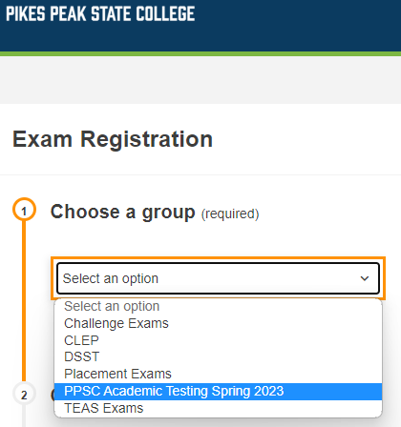
- Choose your exam. If you are taking MAT 1340 Block 1 test for Professor Jim Bond, the exam name will show in the following format: MAT 1340_Block 1 Test_JBond.
Note: Appointments are available after your instructor has submitted your exam. Contact your instructor if your exam is not listed under this step.

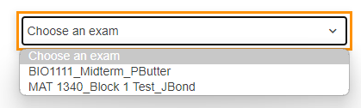

- Click the Choose a Date For Your Exam field to choose an available testing date from the calendar.
  - Available dates will show on bold.
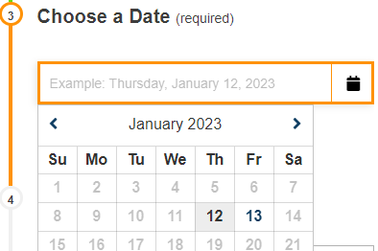

- Click the Choose a Time field to select an available testing time.
  - Exams are stopped and collected 15 minutes prior to closing. We close at 5pm.
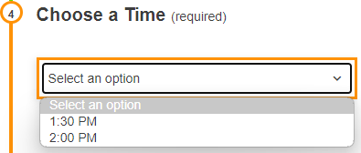
- Enter the test taker information
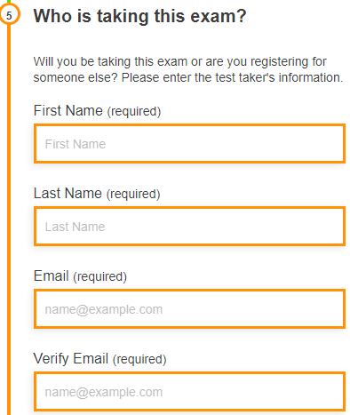
- Read and agree to the Exam guideline acknowledgement.
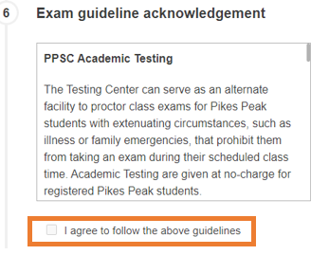

- Under Needed information, enter your phone number and your PPSC student number.

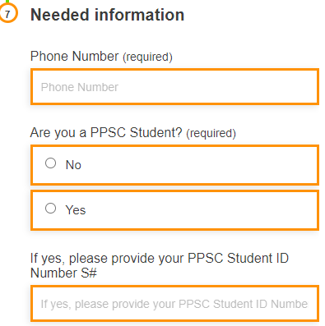

- Click Add to Cart.
- If you need to schedule another exam, click Add Another Exam, and repeat the previous process. Otherwise, review your exam(s) information and click Complete Registration.
  - Although it shows an amount, class/make-up test are offered free of charge for Pikes Peak students.

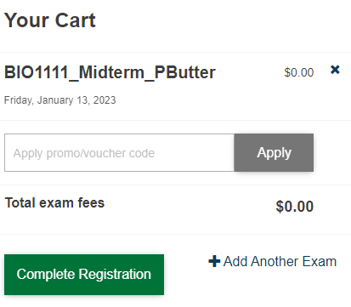

- Upon a successful exam registration, you will receive an immediate email confirmation receipt.
  - You do not have to print the receipt.
- You are allowed to check-in for your exam 30 minutes before your scheduled exam appointment time.

How to Reschedule or Cancel Your Exam Appointment Using RegisterBlast
- Click on the link for the location where your exam is scheduled.
PPSC student schedule here for the Centennial Campus
PPSC students schedule here for the Rampart Range Campus

- Click the My Exams or My History tab at the top of this page.

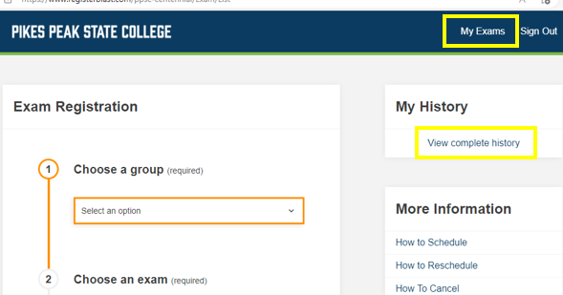

- Enter the email address you used to initially schedule your exam and Click on Continue.

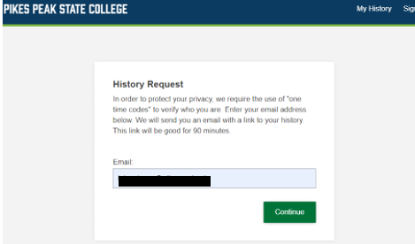

- You will see the following message in the screen

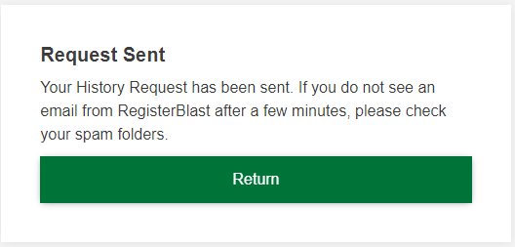

- In a few minutes, you'll receive an email link from support@registerblast.com which is valid for 90 minutes.
- Click the link from the email received.
- A My Exam history page will open. If you don’t see your exam(s) on this page, Click on History. You can also find your upcoming scheduled exams on your Dashboard.

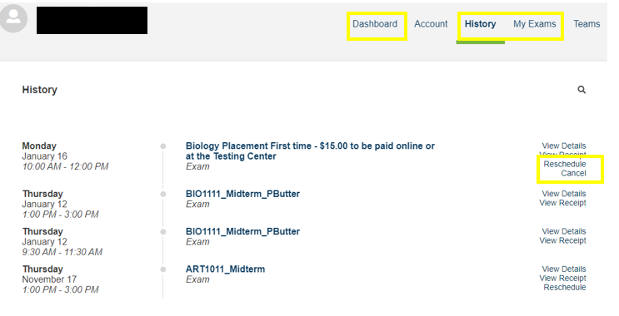

- Find your exam and click Reschedule or Cancel.
To Reschedule
- Click on Reschedule.
- A calendar will appear with the available dates for rescheduling purposes.
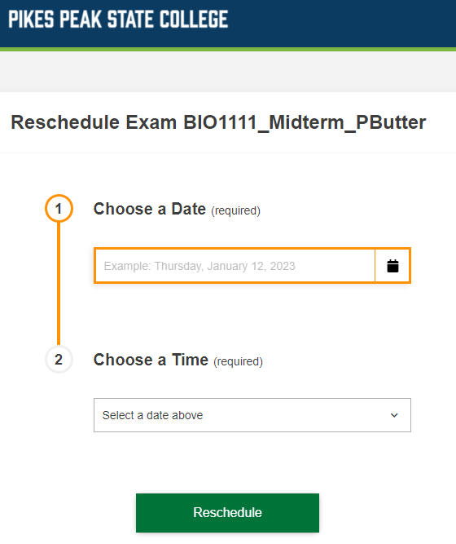

- Choose a new date and time and click Reschedule.
- After you have completed the step above, you will receive a confirmation email notifying you of the new test date.

To Cancel

- Click on Cancel.
- Click "Yes, cancel my registration" if you are sure you want to cancel, or "Keep current registration" if you do not want to cancel your exam.

